Instruction Card
A LESSON ON
Station 2: GLASS ANALYSIS

Glass was found in the sole of the suspect’s runners. Using the water displacement method to measure volume, and the cento-gram balance to measure mass, use the formula for Density: D=m/v and determine if the density of the glass from the suspect’s runners match the density of the broken glass at the crime scene

Procedure (see graduated cylinder images below)

- Record the initial volume in the graduated cylinder in column 1
- Read the final water level in the graduated cylinder with the glass and water and Record in column 2.
- Subtract column 1 from column 2.
Column 2 – Column 1 = Column 3. Record the volume in column 3. Repeat for each sample.
- Use a calculator and use the formula D = m/v and determine the density for each sample.
- Match the density of the each sample to the density of the crime scene glass displayed at the station.
- Identify which sample: A, B, or C matches the crime scene
- Answer the questions.

Backboard Information for
Glass Analysis

Glass fragments can provide valuable evidence to help place a suspect at the scene of the crime. Glass fragments are easy to compare. The comparisons possible with broken or fractured glass include: physical match, probability of common origin, direction of impact, and sequence of impact. Physical match and probability of common origin of two or more pieces of glass can be determined by comparing the physical characteristics of glass samples.

Different types of glass have different physical characteristics such as density. Glass is a hard brittle substance made of silicon oxides and oxides of metals. Adding different oxides of metals when making glass affects its strength and in turn affects its density. Broken glass can be dangerous because it is sharp and can cause serious injury. For this reason tempered glass and safety glass is used in manufacturing automobiles. Tempered glass is made by rapid heating and cooling. This introduces stress to the glass. When tempered glass breaks, it fragments into small squares that do not have sharp edges. Windshields are made of laminated or safety glass. This glass is very strong because it is made by placing a layer of plastic between two sheets of glass and sealing it together.

Sample A (glass) Mass = 43g

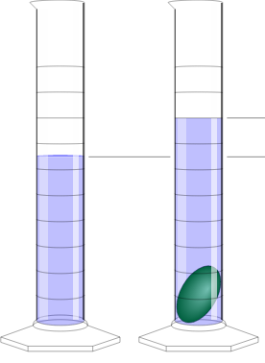

50 ml
65 ml

Initial Volume Final Volume

Sample B (glass) mass = 40g

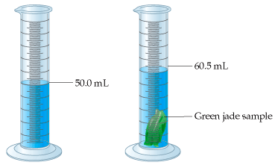

Initial Volume Final Volume
Sample C glass mass = 120g

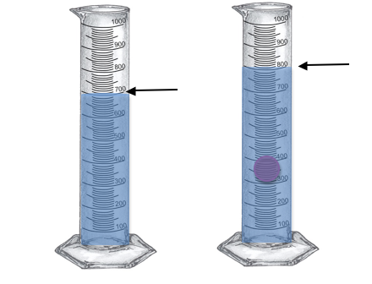
Initial volume= 700mL Final Volume= 800mL

Crime Scene glass: mass= 171

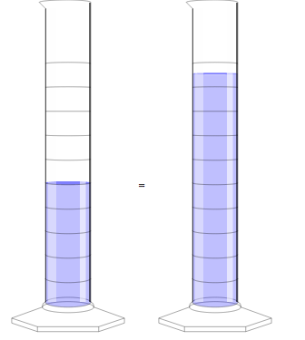
95 ml

Initial volume: 50 mL Final Volume: 95ml

