Instruction Card
A LESSON ON
Station 1: CRIME SCENE ANALYSIS

You are the first detectives on the scene. In case you need to testify in a court of law at a future date you need to record the crime scene. This will be an important document for reference at a later date.

Procedure:
- You must draw the crime scene and measure the distance of the evidence from the fixed points [marked by x]
- The following evidence must be marked and measured, the comb [hair], the apple core [dental], the pop can [lip print] the window frame [fiber, blood type, blood spatter, fingerprints, glass], and the bike tire tread prints.
- Drawing must be in pencil, labeled, ruler used for dotted lines.

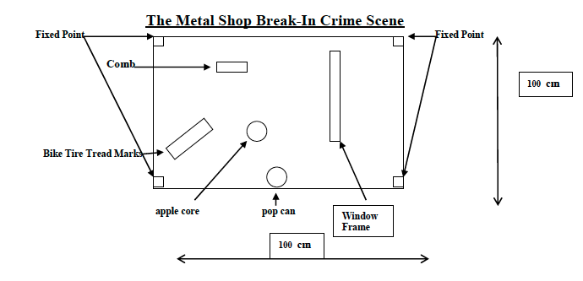
Scale:
1:10

1 cm in drawing = 10cm in real life
Some Photographs of items collected at the crime scene. NOTE: These are not to scale, use the incomplete sketch above to measure the items

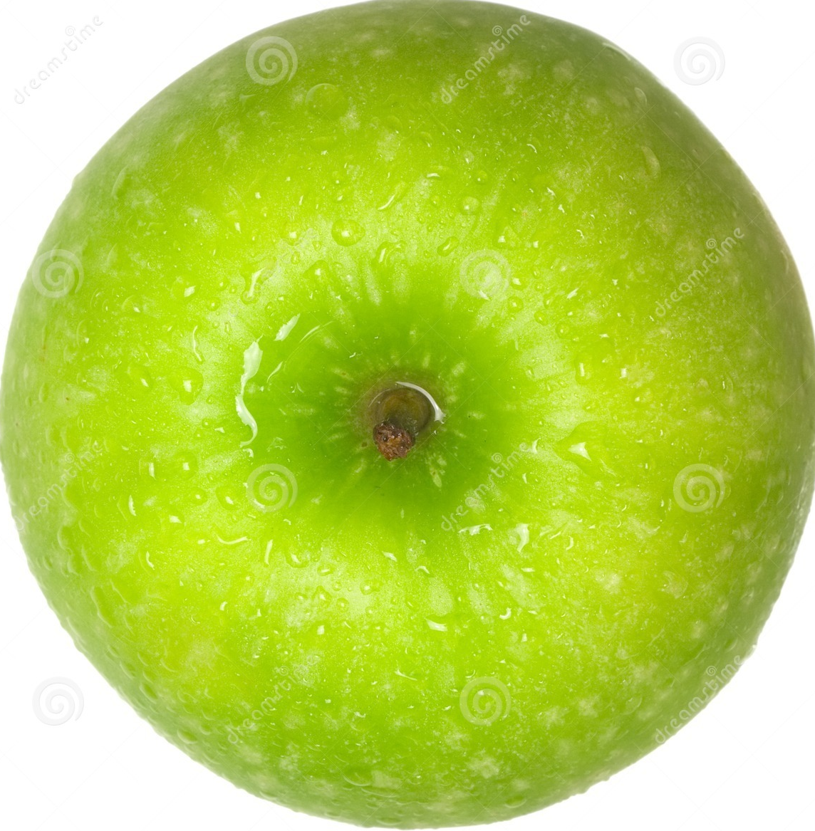
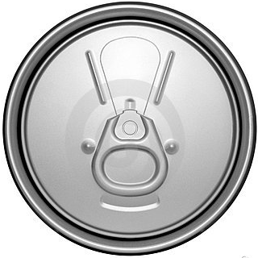

Backboard Information For Crime Scene Analysis

Securing the Scene

As soon as detectives arrive at the scene of a crime they need to protect and secure the area where the crime took place to ensure evidence is not destroyed. Bright yellow crime scene tape is placed around the crime scene and a detective is assigned to record all detectives who pass in and out of the secured crime scene area. Detectives carefully go over the crime scene for clues and collect evidence that may later be used in a court of law. In order to record the crime scene detailed notes are taken as they may be required to refresh the memory of detective years later at a trial. Photographs are taken and a carefully measured sketch is drawn. Although photographs are usually the best record of the scene, they lack specific measurements. Also, sometimes due to the location of the crime scene, photographs are not possible.

Scene Sketch

Once the photographer has completed his or her job, the crime scene detective makes a sketch of the scene. The sketch is always oriented to the North. The location of all objects are carefully recorded and measured. The crime scene detective does not know what objects are related to the crime so it is necessary to collect all evidence for processing. Many times evidence is processed and it is not related to the crime in any way. The objects recorded and collected by the detective are called physical evidence.
To create a scale for the crime scene sketch the detective selects two fixed points at the crime scene. In a room it may be the corners of the room. The crime scene detective uses a tape measure to determine the distance of each object from the fixed point. All distance are carefully recorded. Each object collected and measured is labeled usually with a letter such as A, B, C etc. and at the bottom the sketch the items are identified. A finished sketch is later completed by a skilled artist. It is often used in courtrooms as evidence and may help to recreate the crime scene.

