Science 9 Achievement Exam Review

Knowledge

- I am able to investigate and describe ways that human understanding of Earth and space has depended on technological development:

  - I can identify different perspectives on the nature of Earth and space, based on culture and science.

  - I can describe an Earth-Centred universe

  - I can describe aboriginal views of space

  - I can describe the role of observation in guiding scientific understanding of space

  - I can investigate and illustrate the contributions of technological advances – including optical telescopes, spectral analysis, and space travel- to a scientific understanding of space

  - I can describe, in general terms, the distribution of matter in space (e.g. stars, star systems, galaxies, nebulae)

  - I can identify evidence for, and describe characteristics of, bodies that make up the solar system; and compare their characteristics with those of Earth

  - I can describe and apply techniques for determining the position and motion of objects in space, including:
    - constructing and interpreting drawings and physical models that that illustrate the motion of objects in space.
    - Describing techniques used to estimate distances of objects in space to determine their motion.

  - I can investigate predictions about the motion, alignment, and collision of bodies in space; and critically examine the evidence on which they are based. (e.g. investigate predictions about eclipses; identify uncertainties in predicting and tracking meteor showers)

- I am able to identify problems in developing technologies for space exploration, describe technologies developed for life in space, and explain the scientific principles involved:

  - I can analyze space environments, and identify challenges that must be met in developing life-supporting systems. (e.g. analyze implications of variations in gravity, temperature, availability of water, atmospheric pressure, and atmospheric composition)
  - I can describe technologies for life-support systems, and interpret the scientific principles on which they are based (e.g. investigate systems that involve the recycling of water and air)

  - I can describe technologies for space transport, and interpret the scientific principles involved (e.g. describe the development of multistage rockets, shuttles and space stations; build a model vehicle to explore a planet or moon)

  - I can identify materials and processes developed to meet needs in space, and identify related applications (e.g. medicines, remote sensing, microelectronics, polymers, medical imaging, wireless communication technologies, synthesis of fuels)

  - I can describe the development of artificial satellites, and explain the major purposes for which they are used (e.g. communication, GPS, weather observation)

- I am able to describe and interpret the science of optical and radio telescopes, space probes and remote sensing technologies:

  - I can explain, in general terms, the operation of optical telescope, including telescopes that are positioned in space environments

  - I can explain the role of radio and optical telescopes , in determining characteristics of stars and star systems.

  - I can describe and interpret, in general terms, the technologies used in global positioning systems and in remote sensing (e.g. use triangulation to determine the position of an object, given information on the distance from three different positions

- I am able to identify issues and opportunities arising from the application of space technology, identify alternatives involved, and analyze implications:

- I can recognize risks and dangers associated with space exploration (space junk, fuel expenditure, satellites burning up in the atmosphere, solar radiation)

- I can describe Canadian contributions to space research and development and to the astronaut program (e.g. Canadarm)

- I can identify and analyze factors that are important to decisions regarding space exploration and development (e.g. identify examples of costs and potential benefits that may be considered; investigate and describe political, environmental and ethical issues related to the ownership and use of resources in space.

- Describe what is meant by altitude-azimuth coordinates.

- For each of the following examples, state the altitude-azimuth coordinates of the star and then draw a diagram that illustrates the approximate position of the star.

- Due west and 67 degrees above the horizon

- Due East and the person is looking half-way between vertical and horizontal

5. For hundreds of years, people believed the teachings of _____________________
and this led to the idea that celestial bodies rotated around the earth. This model was called the ___________________________ model. However, it was disproved by ________________________________ who proposed a model where everything roated around the sun, or a ______________________________ model.

- What is the shape of a planets orbit around the sun?

- Construct a tree map that uses the following terms to classify telescopes : telescopes, refracting telescope, optical telescope, reflecting telescope, radio telescopes.

- The following 3 telescope are all examples of__________________ telescopes. Identify the name of each telescope by filling in the boxes on the right, and fill in any missing labels on the left.

________________ lens

_______________ lens
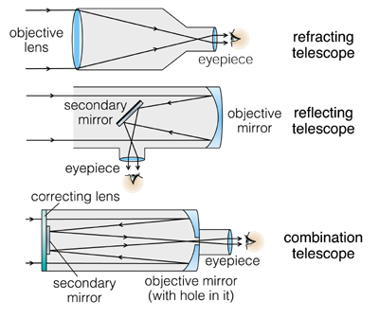

9. Researchers study the spectrum of a star to determine its

  - temperature
  - total mass
  - exhaust velocity
  - composition

- Your friend claims that you need million dollar equipment to get the coordinates of a star. However, you inform her that all you need to determine the coordinates of a star are a/the
  - protractor and a compass
  - protractor and a GPS
  - ruler and a compass
d. compass and an astrolabe

11. Sometimes, celestial objects appear to move in space. This apparent shift in position of a celestial object is called :

A. parralax
B. triangulation
C azimuth
D. interferommetry

12. The main reason that images of celestial objects appear clearer through orbiting telescopes than they do from earth telescopes is that in space,

  - there is little atmosphere to distort the image
  - it can be powered by solar energy
  - there are fewer people to interfere with its operation
  - the telescope is closer to the celestial objects

- Describe the distribution of matter in space by explaining the differences between stars, star systems, galaxies, and nebulae.

- Describe the difference between meteoroids, meteorites, meteors, and meteor showers.

- Numerical Response : Five different people were asked the question : ‘ should we travel in space ?’. Their responses are listed below. Match the person # to the viewpoint that best summarizes their position.

Person 1 Yes, because it will allow us to increase our understanding of the universe by conducting research.

Person 2 Yes, because one day we will be able to send people up into space for pleasure trips. Think of all the money I could make if I started up a space travel company.

Person 3 No, because we are messing up the natural balance of the environment by sending rockets up into space, not to mention all of the space junk we leave floating around up there.

Person 4 No, I believe it is morally wrong to send people flying up into space. Soon people will own resources in space. This is wrong. If we were meant to be in space we wouldn’t be living on earth now.

Person 5 Yes, as president of the United States, I want to govern a larger percentage of space than any other country.

Economic Environmental Ethical Political

- Satellites have become an important part of our society today. Which of the following services do satellites NOT provide?

  - communication
  - entertainment
  - navigation
  - earthquake prediction

Imagine that two new planets have been discovered. Planet X has been found between the orbits of Venus and Earth. Planet Y has been found between the orbits of Jupiter and Saturn. Use the following table to help you answer the questions below.
_____ __ ___
Planet | Diameter (km) | Surface Gravity (Earth = 1) | Surface Material | Atmosphere
Venus | 12 100 | 0.91 | Rock | Carbon dioxide sulfuric acid
Planet X
Earth | 12 756 | 1 | Water, rock | Nitrogen, oxygen, water vapour
Jupiter | 143 200 | 2.5 | Liquid hydrogen | Hydrogen, helium
Planet Y
Saturn | 120 000 | 0.93 | Liquid hydrogen | Hydrogen, helium
__
18 a) Based on the data from the table above, what can you say about the size of planet X relative to Earth and Venus?
_______________________________________________________________________________________________________________________________________________ b) Describe what you would expect the surface of planet X to be composed of.
________________________________________________________________________________________________________________________________________________
c) Would you expect the surface of planet Y to be solid? Explain your answer.
________________________________________________________________________________________________________________________________________________
d) How would the gravity on planet X compare with the gravity on Earth and Venus?

19. _________________________ is the name we give to the process that satellites use to provide information on the condition of Earth’s environment, its natural resources, and the effects of growing populations and cities.

A. telecommunications
B. space probing
C. remote sensing
D. spying

20. While vacationing in a remote area of northern Alberta, Tia looked up at the night sky and noticed a group of starts that seemed to take the shape of a bear called Ursa Major. What she noticed was

A. an elliptical galaxy
B. an asterism
C. a spiral galaxy
D. a constellation

21. The unit we use to measure the vast distances between stars is the

A. kilometre
B. astronomical unit
C. quantum
D. light-year

23. Describe the Doppler effect.

Use the spectral analysis results below to answer question 24.
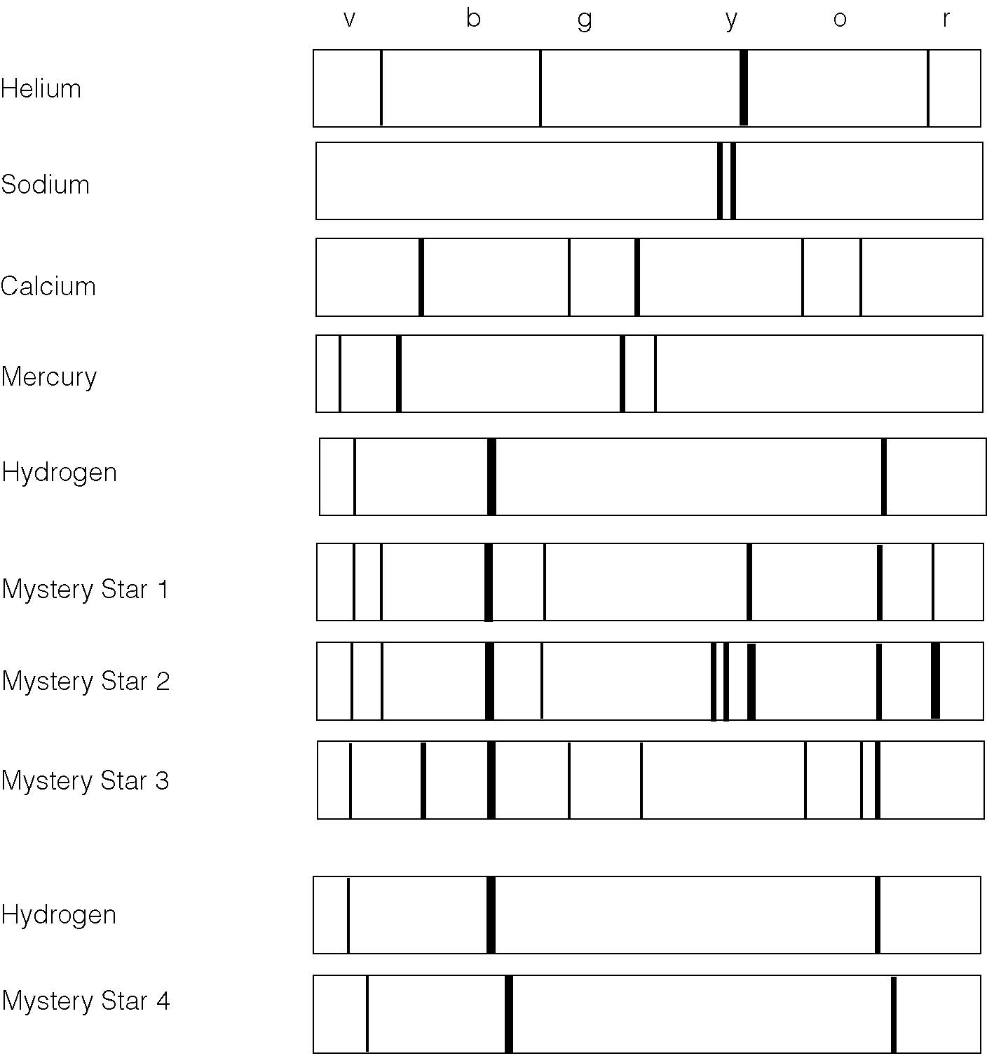

24. a) Which mystery star(s) contain Hydrogen?

b) Which star is said to ‘red-shifted’? What does red-shifted mean?

- What elements does star 3 contain?

Use the following information to answer questions 25, 26 .

NAME (and #) OF PLANET | DISTANCE FROM SUN (in km) | DIAMETER  (in km) | TIME TO SPIN ON AXIS (a day) | TIME TO ORBIT SUN (a year) | GRAVITY (Earth = 1) | AVERAGE TEMPERATURE | CONTENTS OF ATMOSPHERE | MOONS
1.Mercury | 57,900,000 | 4,878 | 59 days | 88 days | 0.38 | -183°c to 427°c | Sodium, helium | None
2. Venus | 108,160,000 | 12,104 | 243 days | 224 days | 0.9 | 480°c | Carbon Dioxide (96%), Nitrogen (3.5%) | None
3. Earth | 149,600,000 | 12,756 | 23 hours, 56 mins | 365.25 days | 1 | 14°c | Nitrogen (77%), Oxygen (21%) | 1
4. Mars | 227,990,000 | 6,794 | 24 hours, 37 mins | 687 days | 0.38 | -63°c | Carbon Dioxide(95.3%), Argon | 2
5. Jupiter | 778,369,000 | 142,984 | 9 hours, 55 mins | 11.86 years | 2.64 | -130°c | Hydrogen, Helium | 16
6.Saturn | 1,427,034,000 | 120,536 | 10 hours, 39 mins | 29 years | 1.16 | -130°c | Hydrogen, Helium | 18
7. Uranus | 2,869,328,000 | 51,118 | 17 hours, 14 mins | 84 years | 1.11 | -200°c | Hydrogen, Helium, Methane | 18
8. Neptune | 4,496,976,000 | 49,532 | 16 hours, 7 mins | 164.8 years | 1.21 | -200°c | Hydrogen, Helium, Methane | 8
9.Pluto | 4,443,000,000 to 7,682,900,000 | 2,274 | 6 days, 9 hours | 248 years | 0.06 | -225°c | Nitrogen, Methane | 1

____ 25. Imagine that you were able to do a detailed spectral analysis of each of the planets. Based on the information above, which 2 planets would you predict would have the most similar spectral analysis results?

a) | Neptune and Pluto
b) | Mars and Earth
c) | Saturn and Uranus
d) | Uranus and Neptune

____ 26. Imagine that you were born and raised on another planet. Assuming that you are about 15 years old on earth, on which planet would you only be about 1/2 year old?

a) | Venus
b) | Neptune
c) | Uranus
d)  e) | Saturn  Mars
- Which of the following may be things that an astronaut experiences after he/she returns to earth?

  - dizziness
  - loss of bone density
  - weaker muscles
  - all of the above

28. In order to do an accurate triangulation, you need

  - a baseline and 1 angle
  - a baseline and 2 angles
  - 2 angles
  - none of the above
- Describe 3 dangers associated with space travel. (space junk, fuel expenditure, satellites burning up in atmosphere, solar radiation etc)

30.. What is/are Canada’s major contribution(s) to space exploration/travel?

31. What is an advantage of a radio telescope over an optical telescope?

32. Which planets are considered to be inner planets? Outer planets? Describe 2 major differences between outer an inner planets.

33. Describe the difference between a lunar and a solar eclipse.

